**Criterion C: Development**

**Techniques Used**

Grids

The product is sitting on top of a grid that has both an x-axis and y-axis.

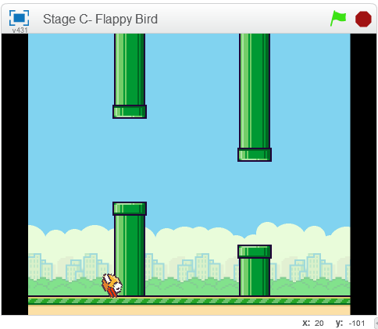   
As you can see here, there is an actual indicator of your location on the grid.

I use the grid to my advantage to my script. For example, I use the grid to set up the bird’s position in the very beginning of the game, which can be found in Appendix 1a.

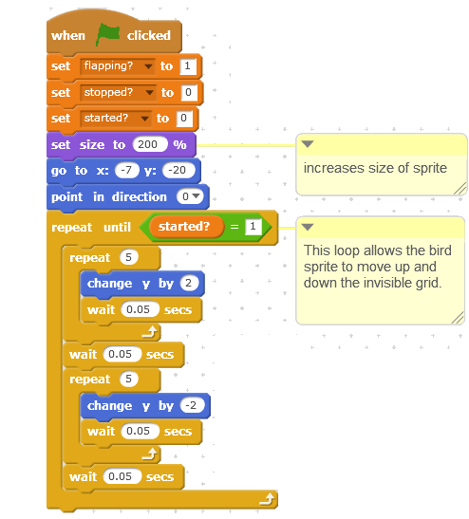As you can see in the image above, the second line indicates that the sprite must go to a specific position in the grid.

Moreover, the same can be found with the pipe script where the script commands the pipe to change its y-axis position randomly after creating each clone of itself. Also, right below that line the x-axis of the sprite is changed to create a flowing movement with the multiple pipes and a distance between the pipes.

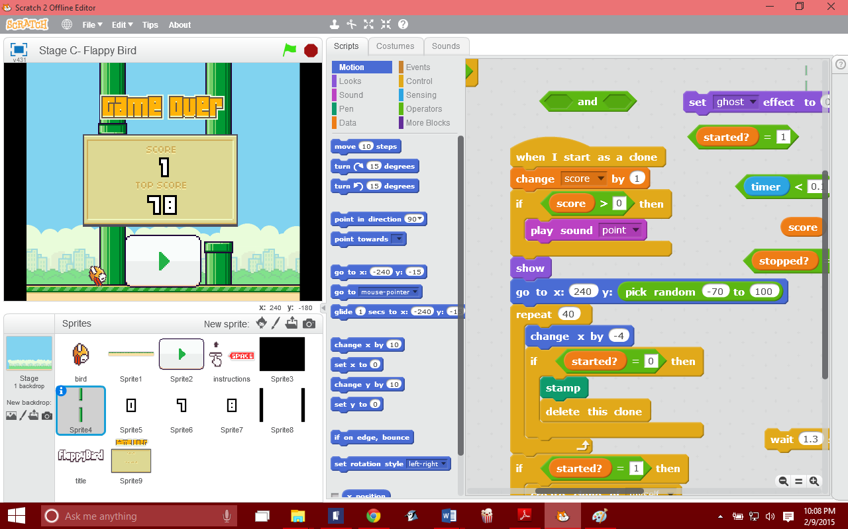

Here is an example of a cloned pipe with a changed y-axis position and the distance between the two pipes was decided by the x-axis.

Variables

* xVel – velocity of the a moving sprite on the x-axis of the grid
* yVel – velocity of the a moving sprite on the y-axis of the grid
* flapping – this variable represents the flapping motions of the bird sprite
* black – used to represent the black screen sprite in order to create a shifting animation
* hit – this is useful for situations where the bird sprite comes into contact with the obstacle sprites (i.e. the ground and the pipe sprites)
* started – this variable is used to announce that the program has been initiated
* stopped – this variable is used to announce that the program has stopped
* score – it is used to hold the current score of the player
* Score1 – this uses a database to collect the current highest score of the player

Looping

The program used plenty of loops because it allows us to use a command in a limitless manner. For example, in Appendix 1c, we can see that the loops allow us to create an infinite amount of clones of the pipe sprite. Moreover, it allows the pipes to move consistently.

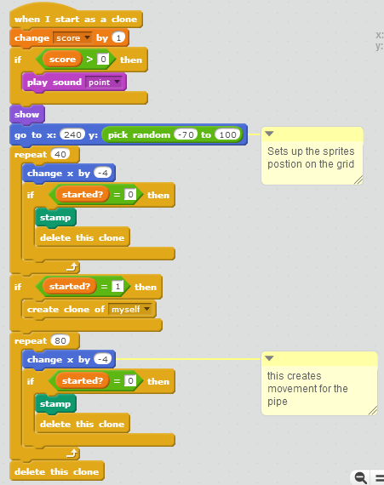

In Appendix 1f, loops are also used to create an animation that occur automatically. With the loop, if the bird sprite is not hitting an obstacle during gameplay, then it will switch costumes every 0.07 seconds. Thus, it gives the illusion of flying.

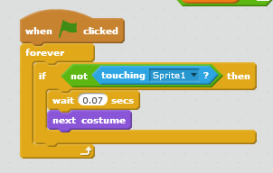

Also, in Appendix 1g, loops are used to increase the depth of the experience of the player by playing sounds during gameplay. With the loop, a sound will play as a reaction to the player’s input. In this set of commands, it tells the program if the mouse is clicked while the game was on, then it will play a sound after moving the sprites position on the y-axis.

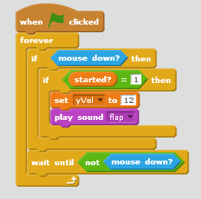

**Additional Information**

1. Appendix 1 – Sprites
2. Appendix 2 – Bibliography

**Word Count:** 485